April 2019
Executive Directors Report

Staff Training
Staff found the IL Conference in Provo to be very beneficial.

Building Update
- During the March 19th IHC Real Estate meeting, the group found that the donation of the property on 400 E and 500 S in St. George to have merit.
- A meeting has been scheduled with the head of IHC in St. George for April 25th at 1:30. A brief PowerPoint presentation has been developed and will be presented by Greg Bartholomew (Chair of Friends of Red Rock) and Barb Lefler at this meeting.

UDOT Certifications and Assurances (See docs in packet: 2019-certs…, Signature pages…)
Each year, RRCI is required to validate its relationship with UDOT and joint owners of the accessible bus. Since there is not an attorney on the board, we have used a nonprofit attorney out of Salt Lake City to assist RRCI with the required documents. There is a requirement to loop the board in and have them take a vote during a board meeting to allow me to proceed.

Executive Director Health
The last half of my treatments was fraught with side effects. I chose to slow the treatment down and have 3 of nine chemo treatments once a week; six more weeks to go. I will be taking some time off in May and June to continue with surgery, radiation, etc.

Consumer Surveys

Q1 Graded Answers
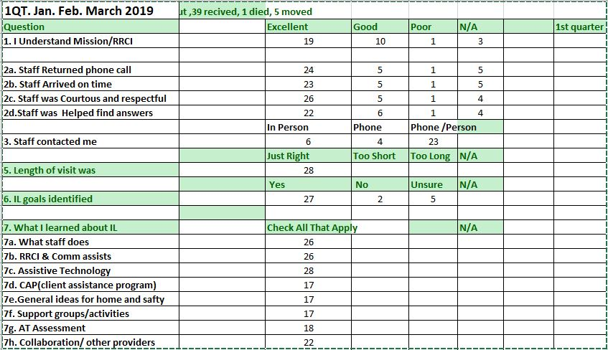

Written Comments:
#9 HOW DID STAFF HELP YOU THE MOST?
- They lent me a wheelchair when my main chair was broken or getting fixed. They usually gave me wheelchair parts when I needed them. They were able to get me a nice shower/bath chair.
- Training to use cane, helped with hearing aids, and talking watch.
- By getting a walker
- Looking into hearing aids.
- Assisting in providing assistive technology
- Got us a raised toilet seat, bars for bathroom, and a chariot lift.
- They called and I did not feel I need help other than my spouse
- I have learned so much over the years and I’ve been given opportunities to go to Ninja Conference as a participant and a mentor.
- Supplied me with the items I needed
- Keeping me informed
- For me I get out o the house and have fun cooking class and craft.

#10 HOW CAN RRCI IMPROVE OUR SERVICES TO HELP YOU MORE EFFECTIVELY?
- They can keep a good supply of spare wheelchairs and wheelchair parts, etc. How to get HELP, I am lost at this time or (stage) in life.
- Can’t think of a better experience!
- Would like to get a chair lift for husband
- At this point my spouse is able to help with my needs.
- I mainly want to improve my cooking skills.
- They are doing great.
- Just fine the way it is
- Speech therapy
#11 PLEASE SHARE ANY OTHER THOUGHTS YOU MAY HAVE ABOUT YOUR EXPERIENCE WITH RRCI AND STAFF?
- I might need your help with an abusive wheelchair vendor and sadistic medical equipment specialist, named Chris Beckstead. In the past 3 years, this shady wheelchair vendor started out as AAMCO Mobility, and now their new name is NuMotion. An honest company that provides wheelchair service repair and does not cheat Medicare/Medicaid, does not change their business name every couple month!
- Gordon is grateful for the help he has received. He enjoys the meetings and social activities. Everyone is so kind and helpful.
- What is this about? RR helped me get my hearing aids. I’ve received home heath from Zions Way. I don’t know why you keep sending me forms to fill out.
- You need more staff.
- They hold a meeting at the library once a month. I have not been able to attend, but I feel it is a wonderful idea to get people out and active. They did Bingo one time and I thought that was such a fun idea. I will start going when I feel better. This is a fantastic idea.
- HUGE thanks to Jill and Brad for ongoing help. Travis is communicating!!!
- Thank you for you Hurricane location!
- They have been great.
- It is a wonder place for me to go and be happy and meet new friends and learn more about thing that I never thought I could do by myself
- Thank you.
- Alison and Barbra have helped me so much and I’m grateful for all they do for me.
- Register my use of a 4-wheel walker that I borrowed from Brad McCarrel. He has it back now.
- They are very helpful and great to work with. Renae Lagere was great!
- Awesome

