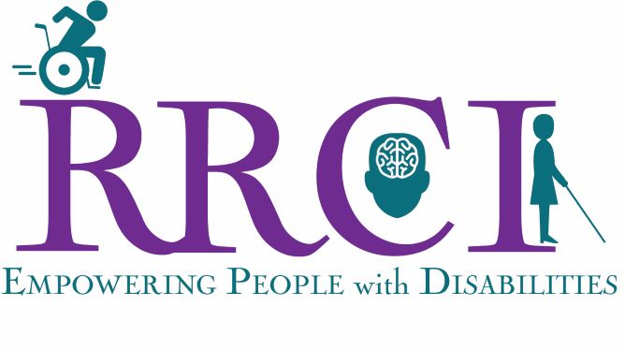

Be A Volunteer Youth Mentor

RRCI is always looking for friendly part time volunteers who would love teaching youth grades 7-12 in a special education classroom setting. Curriculum and training provided, 2-4 hours weekly.
Position is compensated. Must be 16 or older. Individuals with disabilities encouraged.
If interested, please contact us:
M-Th 7:30am-4:30pm, Fri 7:30am-1:30pm
168 N 100 E Suite 101, St. George, UT 84770
Phone: 435-673-7501 or jennifer@rrci.org or kayla@rrci.org

